AKTIION 2023 on

AKTIION 2023 Proceedings – Online Version
International workshop on Training, Industrial and Organisational Engineering
(editors)
Conakry, Guinea, 07-09 November 2023
The contribution of Industrial Engineering to socio-economic development in Africa

Template for Papers
Author Name 1, Author Name 2
Institution / Company
Address, City Code City, Country
Author.One@institution.org, Author.Two@institution.org
web-page: https://aktiion2023.sciencesconf.org
Author Name 3, Author Name 4
Institution / Company
Address, City Code City, Country
Author.Three@institution.org, Author.Four@institution.org
web-page: https://aktiion2023.sciencesconf.org

ABSTRACT
This document presents the instructions needed to prepare short papers to be included in the proceedings of the AKTIION 2023 on “The contribution of Industrial Engineering to socio-economic development in Africa”. All papers should be written in English or in French. In order to achieve graphical consistency, the papers should be preferably written using Microsoft Word. The first page should contain the paper’s title, authors, first author affiliation, address, e-mail and affiliation web-page, followed by the Abstract's text and the Keywords (up to six). The typeface used for the abstract is a 12 point Times-Roman.
Authors are requested to submit Papers (up to max. 12 A4 pages) in electronic form (MS-Word or PDF) via the Conference web page https://aktiion2023.sciencesconf.org
The abstract length should be kept within the first page of the document only and should be as extensive as possible. The Introduction section and the other sections to follow will start from page 2 onwards. The Proceedings of the Conference will be published online and will contain the papers accepted for presentation in the conference, including posters and invited talks’ abstracts. The Papers submitted to AKTIION 2023 will be considered for reviewing purposes and for pre-selection of the papers as candidates for the Conference Journal Special Issues.

Keywords: Short Paper, Template, AKTIION 2023

INTRODUCTION
It is expected that authors will submit carefully written and proofread material. Spelling and grammatical errors, as well as language usage problems, are not acceptable. There is no strict limitation to the number of pages, but it is suggested that the short paper length should not exceed 8 A4 pages.
Papers should clearly describe the background of the subject, the authors' work, including the methods used, as well as concluding discussion on the importance of the work. Papers are to be prepared in English (British or American) or in French (France or Canada). Technical terms should be explained unless they may be considered to be known to the broader research community. Acronyms should be written out at their first appearance.

Fonts
Papers should use 12-point Times New Roman font. The styles available are bold, italic and underlined. It is recommended that text in figures is not smaller than 10-point font size.

Tables and Figures
Figure captions and table headings should be sufficient to explain the figure or table without needing to refer to the text. Figures and tables not cited in the text should not be presented in the paper. The following are example for Table 1 and Figure 1.

Table 1: Title of Example Table
Header | X | Improved
(Flow control valves) Air operated valves | 4 | Yes
Check valves | 2 | Yes
Line discharge check valves | 4 | Yes
Pump discharge check valves | 3 | Yes
Motor driven pumps | 2 | Yes
Motor driven pumps | 2 | No

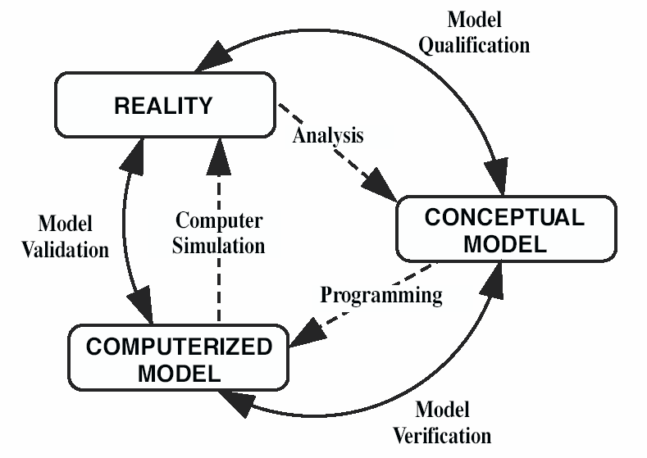
Figure 1: Verification, Validation and Qualification

Tables and figures should be placed close after their first reference in the text. All figures and tables should be numbered. Table headings should be centered above the tables. Figure captions should be centered below the figures.

SECTIONS

Main sections
The titles of the main sections should be placed left and written with uppercase bold Times-Roman 12 point font. In order to avoid orphans on the text, make sure that at least three lines of text are typed after the section title and before any page break. The graphical appearance of the publication will profit from your care.

Subsections
The subsection titles should be written placed left, with a bold Times-Roman font, 12 point. Only the first letter of the title is uppercase, being all others lowercase. In order to avoid orphans on the text make sure that at least three lines of text are typed after the subsection title and before any page break.

CONCLUSIONS
Conclusions should state concisely the most important propositions of the paper as well as the author’s views of the implications of the obtained results.

REFERENCES
References should be placed at the end using 12 point Times-Roman and cited as [1] or [1, 2]. The references should be listed in the same order as cited in the text. See examples below.

- K.N. Flam, S.B. Rem, G.A. Tim, A. Moss, A. Afzu, “Example 1 of Reference for the AKTIION 2023 Short Paper Template”, EPRI TR-100382, Electric Power Research Institute, CA., USA, 2002.
- N. Watson, “Example 2 of Reference for the AKTIION 2022 Short Paper Template”, Springer-Verlag, Berlin, Germany, 2010.

